41. Sales and Profit Analysis: a) Load the “sales_data.csv” file into a Pandas data frame, which contains columns “Date,” “Product,” “Quantity Sold,” and “Unit Price”

b) Create a new column named “Total Sales” that calculates the total sales for each transaction (Quantity Sold * Unit Price).

c) Calculate the total sales for each product and the overall profit, considering a 20% profit margin on each product. Display the top 5 most profitable products.

CODE:

import pandas as pd

df = pd.read_csv(r"C:\Users\jampa\Downloads\sales_data.csv")

df['Total Sales'] = df['Quantity Sold'] * df['Unit Price']

product_sales = df.groupby('Product').agg({'Total Sales': 'sum'}).reset_index()

product_sales['Profit'] = product_sales['Total Sales'] * 0.20

overall_profit = product_sales['Profit'].sum()

top_products = product_sales.nlargest(5, 'Profit')

print("Total Sales per Product:")

print(product_sales.sort_values('Total Sales', ascending=False).to_string(index=False))

print(f"\nOverall Company Profit: ${overall_profit:,.2f}")

print("\nTop 5 Profitable Products:")

print(top_products[['Product', 'Profit']].to_string(index=False))

OUTPUT:

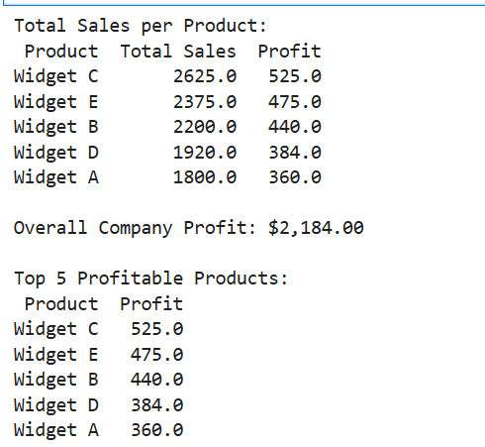

Dataset:

|  |  |  |  |
| --- | --- | --- | --- |
| Date | Product | Quantity Sold | Unit Price |
| 1/1/2025 | Widget A | 100 | 10 |
| 1/2/2025 | Widget B | 50 | 20 |
| 1/3/2025 | Widget C | 75 | 15 |
| 1/4/2025 | Widget A | 80 | 10 |
| 1/5/2025 | Widget B | 60 | 20 |
| 1/6/2025 | Widget D | 90 | 12 |
| 1/7/2025 | Widget E | 40 | 25 |
| 1/8/2025 | Widget C | 100 | 15 |
| 1/9/2025 | Widget D | 70 | 12 |
|  | Widget |  |  |
|  |  |  |  |